Algorithm Analysis
Handout 2
Deadline October 10

Exercise 2.1
For each of the following equations show whether it is true or false:
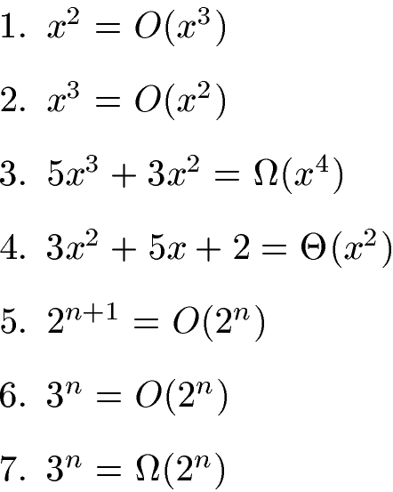

Exercise 2.2
The Max-Heapify algorithm in your textbook has a recursive definition:
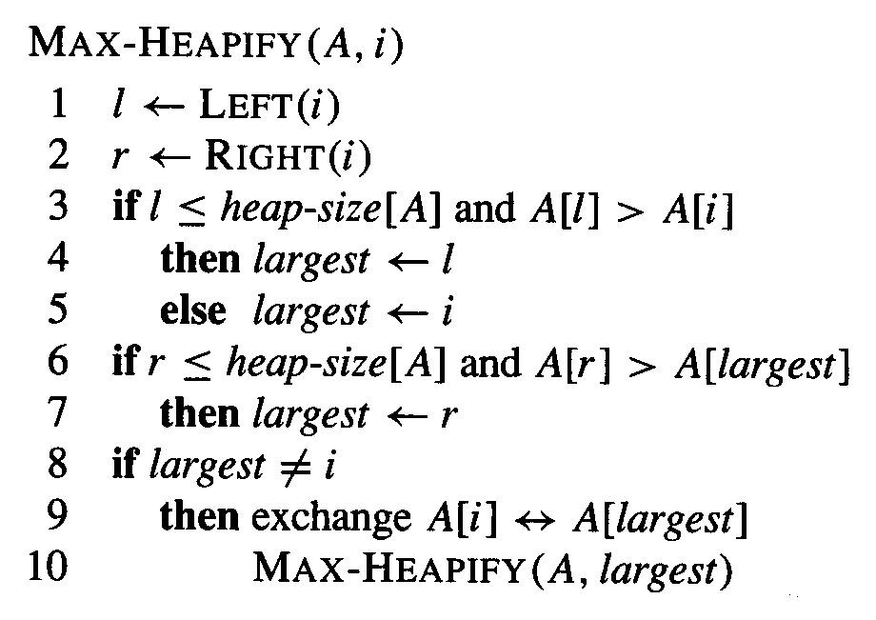
Give an iterative (loop – based) definition of the Max-Heapify algorithm.

Exercise 2.3
Using Figure 6.4 on page 161 in the textbook as a model, illustrate the operation of Heap sort on the array A = [6, 12, 1, 28, 7, 19, 22, 8, 2]

Exercise 2.1

- True(Square is lower bound to cubic. Cubic is much larger than square.)
- False(Cubic is upper bound to square.)
- False(x^4 is upper bound to cubic. But the omega means is it upper bound of the given equation?, so it’s not true.)
- True(The theta means is it average of the given equation?, so the equation’s degrees are same with square and square.)
- True(2^(n+1) means 2*2^n, and 2 can be removed.)
- False(3^n is much larger than 2^n)
- True(3^n is upper bound to 2^n)

Exercise 2.2
while ( i < = heapsize) {
le <- left(i)
ri <- right(i)
if (le<=heapsize) and (A[le]>A[i])
largest <- le
else
largest <- i
if (ri<=heapsize) and (A[ri]>A[largest])
largest <- ri
if (largest != i)
{
exchange A[i] <-> A[largest]
i <- largest
}
else
break
}

Exercise 2.3

[6, 12, 1, 28, 7, 19, 22, 8, 2]
[6, 28, 1, 12, 7, 19, 22, 8, 2]
[6, 28, 22, 12, 7, 19, 1, 8, 2]
[28, 6, 22, 12, 7, 19, 1, 8, 2]
[28, 12, 22, 6, 7, 19, 1, 8, 2]
[28, 12, 22, 8, 7, 19, 1, 6, 2] Since line 1 to here(line6), this process is build up the max heap
[22, 12, 19, 8, 7, 2, 1, 6] [28]
[19, 12, 6, 8, 7, 2, 1] [22, 28]
[12, 8, 6, 1, 7, 2] [19, 22, 28]
[8, 7, 6, 1, 2] [12, 19, 22, 28]
[7, 2, 6, 1] [8, 12, 19, 22, 28]
[6, 2, 1] [7, 8, 12, 19, 22, 28]
[2, 1] [6, 7, 8, 12, 19, 22, 28]
[1] [2, 6, 7, 8, 12, 19, 22, 28]
Each line(from line 7 to 14) is Max-heapify.(I removed the process building max heap.)

∴[1, 2, 6, 7, 8, 12, 19, 22, 28]

